Architecture Diagram

1.System Context
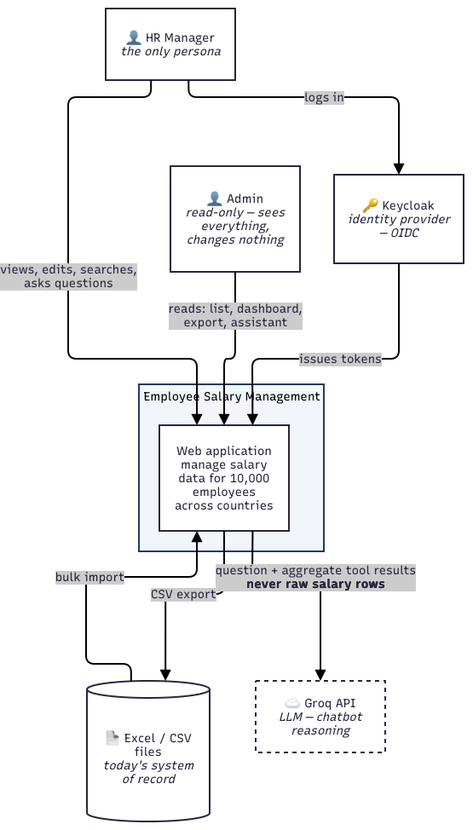

2. Containers
Separation of concerns. The application service and the chat service solve different problems. One manages salary data: tables, transactions, effective-dating, audit. The other manages a conversation: prompts, tool schemas, model calls, refusals. Those have nothing in common except that the second one needs answers the first one already produces.

So, the application exposes its capabilities as an API, and the chat service consumes that API as its tools. The chatbot does not learn the schema, does not hold a transaction, and does not know what effective dating is.
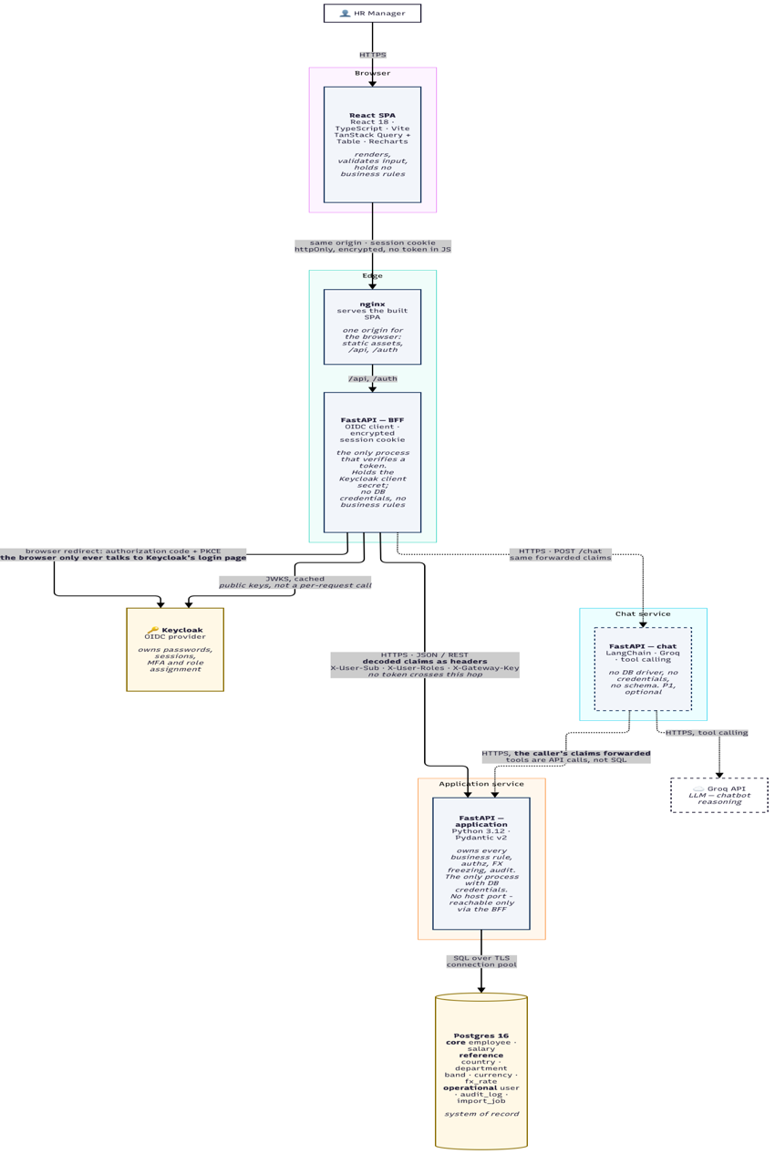

3.Deployment & Trust Boundaries
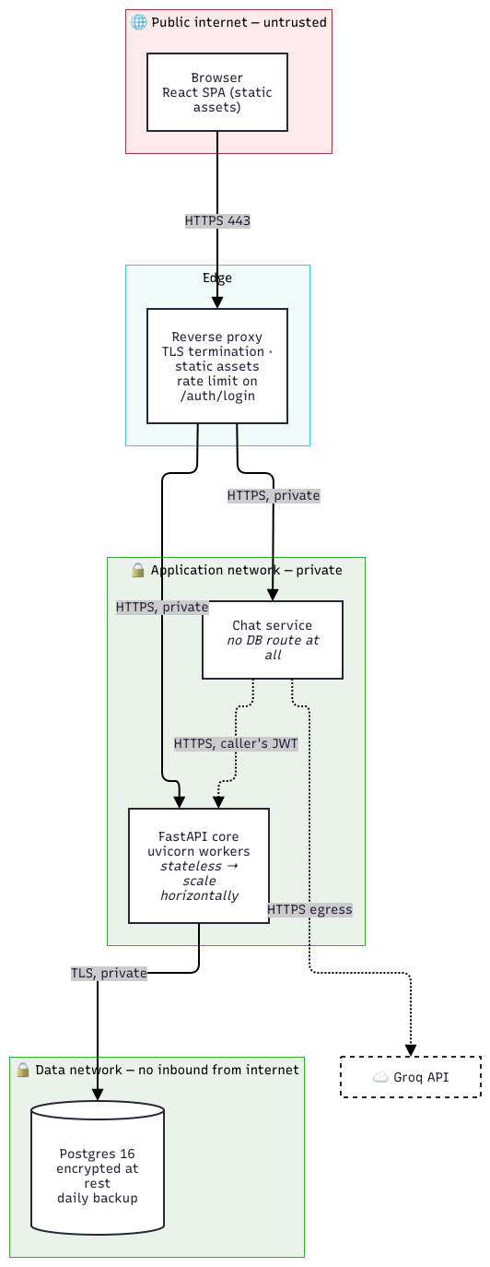

4. Request Flow


